**3D large deformation modeling of the 2020 Gjerdrum quick clay landslide**

Quoc-Anh Tran1, Agnete Rogstad1, Ivan Depina1, Fabricio Fernández2, Gebray Habtu Alene1, Gustav Grimstad1, Steinar Nordal1

1 Department of Civil and Environmental Engineering, Norwegian University of Science and Technology, Norway.

2 Department of Civil and Environmental Engineering, Pontifical Catholic University of Rio de Janeiro, Brazil.

ABSTRACT

A quick clay slide in Gjerdrum, Norway, occurred at 4 a.m. on 30th December 2020 killing 10 people and destroying houses, roads, and other infrastructures. Approximately 1.35 million cubic meters of clay were released, a large volume liquefied, and debris was transported almost two kilometers downstream. An investigation following the slide determined that the slide was initialized in a 30-meter-high slope after 2-to-2,5-meter vertical erosion in a small creek running along the toe of the slope. After the initiation, the slide developed retrogressively in the order of 500 meters backward and sideways over a period of about 2 minutes. A conventional geotechnical slope stability analysis explains the initial slide. However, more advanced numerical tools are needed to simulate the retrogressive mechanism and the debris flow. The aim of the paper is to demonstrate a 3D Material Point Method model to capture some of the mechanisms involved from initiation until the debris comes to rest, and how this method can be used to reproduce and study the processes involved in large deformation landslides.

KEYWORKS: quick clay, sensitive clay landslides, Material Point Method, large deformation modeling

# Introduction

Scandinavia and Canada are at risk of large-scale, sensitive clay landslides. For example, Norway has experienced large, quick clay landslides larger than 50.000m3 approximately once per year since 1970 (J.S. L’Heureux, 2018). A tragic example occurred in December 2020 when a fatal sensitive clay landslide in Gjerdrum, Norway claimed ten lives and caused extensive damage to homes and infrastructure (Figure 1). These landslides are predominantly progressive or retrogressive due to significant softening behaviour of the sensitive clays after reaching peak strength. The Gjerdrum landslide was classified as a quick clay retrogressive flow landslide under the Varnes' classification of landslides (Hungr et al., 2014). This failure mechanism is typical in Norway. A retrogressive quick clay landslide has three phases: an initial slide in the triggering phase, the growth of the unstable soil volume and the post-failure mass flow phase. In the triggering phase, natural factors such as erosion or human activity initiates a small slide. Following this initiation, the involved soil mass liquefies and flows out of the slide pit, leaving behind a steep and often unstable back scarp. In the case of the Gjerdrum landslide, erosion is believed to have been the triggering event and the primary cause of the disaster (Ryan et al., 2021). Detailed studies of Lidar data revealed that the creek at the bottom of the slope had eroded 2-2.5 m vertically from 2007 to 2020 (Figure 2). The Gjerdrum landslide is reported to have occurred retrogressively in nine stages (Figure 3). This conclusion was drawn from various sources, including photos, videos, geotechnical and hydrogeological investigations, and witness testimony.

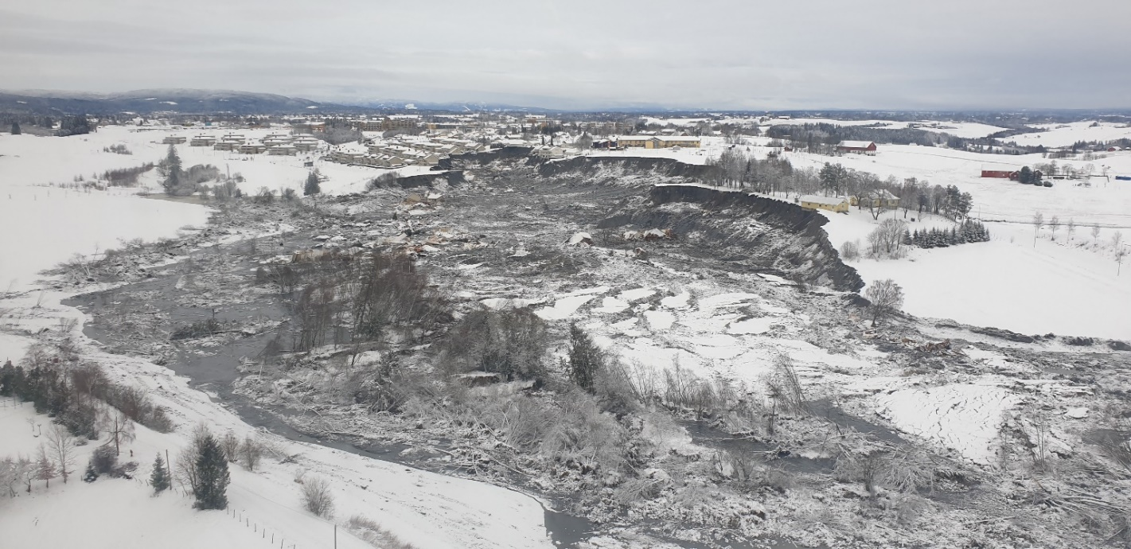

Figure 1 Gjerdrum landslide (photo from NVE)

|  |  |  |
| --- | --- | --- |
|   **(a) Google map** |  |   **(b) Elevation model** |
|   **(c) Erosion monitoring** | | |

Figure 2 Erosion mechanism (Ryan et al., 2021)

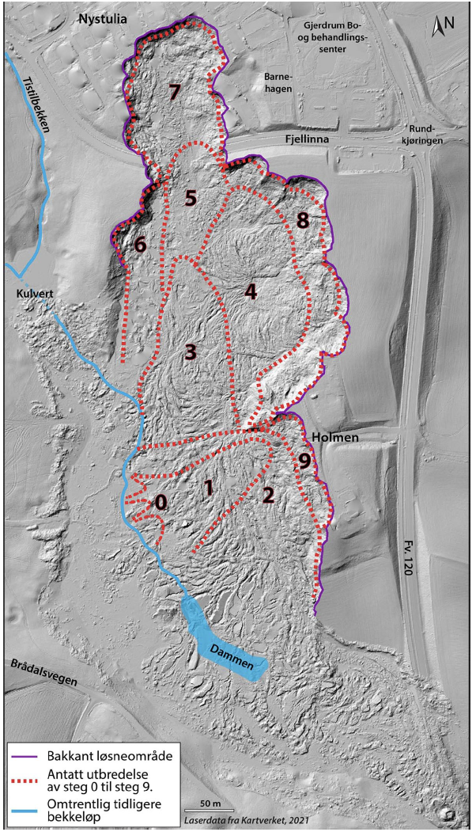

Figure 3 The nine stage of the Gjerdrum landslide (Ryan et al., 2021)

It is essential to model the initiation and mobility of quick clay landslides to improve future quick clay landslide risk management. Although conventional Finite Element or Limit Equilibrium methods can be used to determine the margin against failure (Locat et al., 2013; Locat et al., 2011), they are insufficient for capturing the mobility and development of the landslide. The mass movement can be modeled by incorporating depth-averaged balance equations, enabling us to analyze the motion of the soil masses in quick clay landslides (Liu et al., 2021). However, these depth-averaged models are incapable of replicating the nature of retrogression. Furthermore, the depth average models require to determine how much soil is released in advance which should be determined implicitly as a result from the simulation.

Hence, particle-based methods have gained popularity as numerical tools for analyzing both the initiation and mobility of sensitive clay landslides. Examples include the coupled Lagrangian-Eulerian method (Dey et al., 2015), the Material Point Method (Tran & Solowski, 2019) , and the Particle Finite Element Method (Zhang et al., 2020). Notably, these studies have been conducted under plane strain conditions without accounting for three-dimensional effects. Nevertheless, when dealing with natural slopes characterized by layered soils and complex topography, slope stability analyses for two-dimensional and three-dimensional slopes can yield significantly different results (Alison McQuillan, 2021).

This study uses the Material Point Method to perform a 3D analysis of the Gjerdrum quick clay landslide as a case study. To understand the advantages and limitations of the model, the simulation results are compared to field observations from Gjerdrum. The 3D Material Point Method allows for the simulation of (1) the failure initiation associated with strain localization and (2) the mobility of the liquefied soil such as the size, direction, and distance of progressive failure.

# Research Methodology

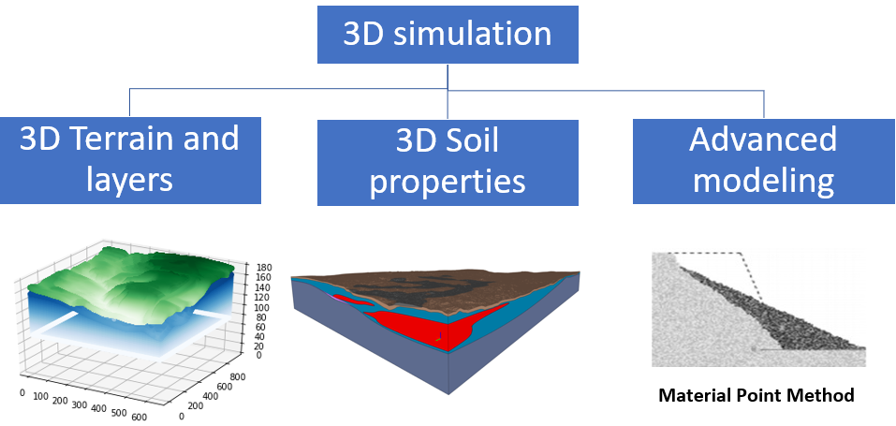

Figure 4 Three-dimensional simulation

For a comprehensive 3D analysis of the Gjerdrum quick clay landslide, it necessitates the integration of three key components (as shown in Figure 4):

- 3D terrain and soil layers reconstruction,

- Assignment of 3D Soil Properties for Material Points,

- Utilizing Material Point Method for Large Deformation Modeling.

To facilitate this 3D analysis, several key hypotheses are made.

## Undrained Elastoplastic Tresca Model

Given the rapid nature of the landslide, an undrained condition is assumed. Hence, an elastoplastic Tresca model is used to represent the undrained behavior of the clay. There is no plastic volume change during shearing since the dilation angle is equal to 0. This model incorporates shear strength degradation, which decreases with increasing plastic shear strains. The undrained shear strength degradation is described by:

|  |  |
| --- | --- |
| $$s_{u}(,S_{t})=s_{u,ref}[\frac{1}{S_{t}}+{(1-\frac{1}{S_{t}})e}^{-3/{}_{95}}]$$ | (1) |

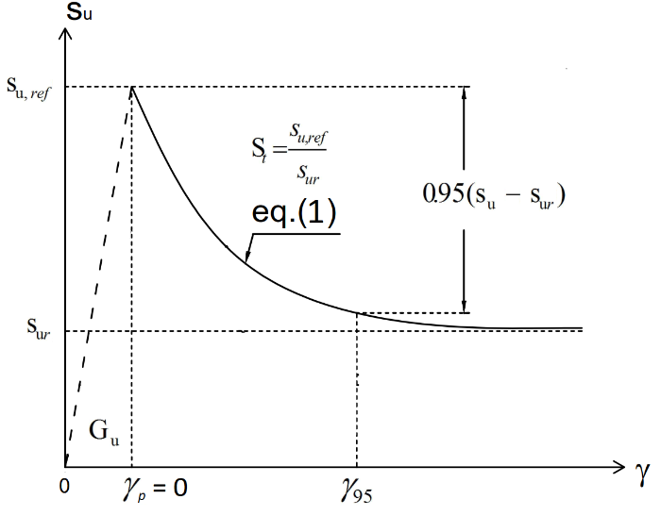

Figure 5 Constitutive model for sensitive clays

$where$ is the current accumulated shear strain, ${}_{95}$ is the accumulated shear strains required to obtain 95% reduction of shear strength and the sensitivity St is the ratio of undisturbed over remoulded undrained shear strength $s_{ur}$:

|  |  |
| --- | --- |
| $$S_{t}=\frac{s_{u,ref}}{s_{ur}}$$ | (2) |

## Soil Layer Classifications

Soil layers, as per soil investigations, consist of three main layers: bedrock, non-sensitive clay, and quick clay. Bedrock is considered rigid, non-sensitive clay layers are modeled with a Tresca softening model and low sensitivity (1-10), while quick clay layers are modeled using the Tresca softening model with high sensitivity (20-100). The undrained shear strengths are obtained from CPTUs retrieved from (Multiconsult, 2021a-b) for the entire area.

## Two Phases of Simulation

The simulation is divided into two phases:

- Phase 1: Establishing initial stresses under gravity using the estimated topography data from 2007 and undrained soil parameters.

- Phase 2: Utilizing interpreted soil properties to study the retrogressive failure process. Here, the topographical differences between 2015 and 2007 are removed to mimic erosion. Given negligible erosion between 2015 and 2020 (see Figure 2), the topography of 2015 represents the initial terrain elevation before the slide. Terrain elevation and soil layer data are sourced from the 3D LeapFrog model (Multiconsult, 2021a-b).

## Model Scope and Limitations

The model does not consider the run-out distance during the landslide mobility but focuses on the analysis of the triggering and retrogressive failure mechanism. The model does not account for several important factors related to the failure including soil anisotropy, hydraulic conditions, weather conditions or external loads attributable to buildings, or snow accumulations.

In the upcoming sections, we will delve into each of these components in detail, including the 3D reconstruction of terrain and soil layers, the assignment of 3D soil properties to material points, and the application of the Material Point Method for modeling large deformations.

# Three-dimensional terrain and layer model reconstruction

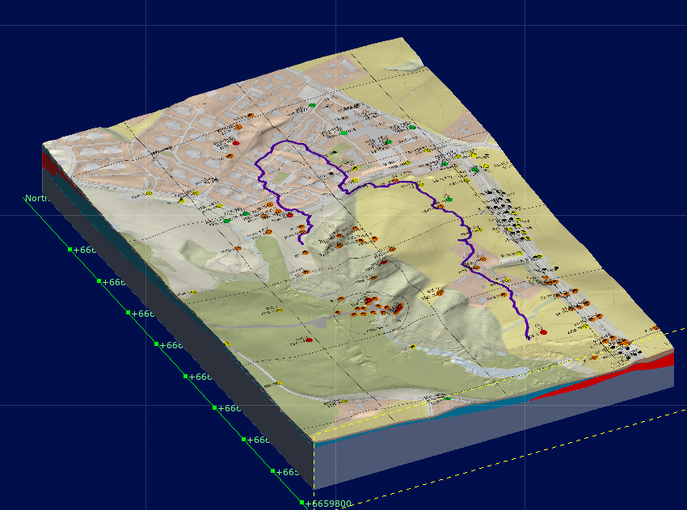

Figure 6 Terrain model in LeapFrog (Multiconsult, 2021a-b)

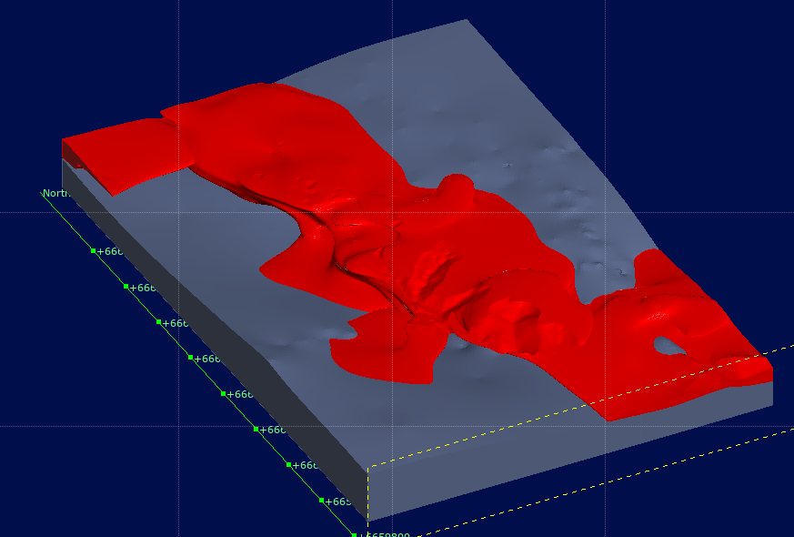

Figure 7 Bedrock (gray) and quick clay (red) layer in LeapFrog (Multiconsult, 2021a-b)

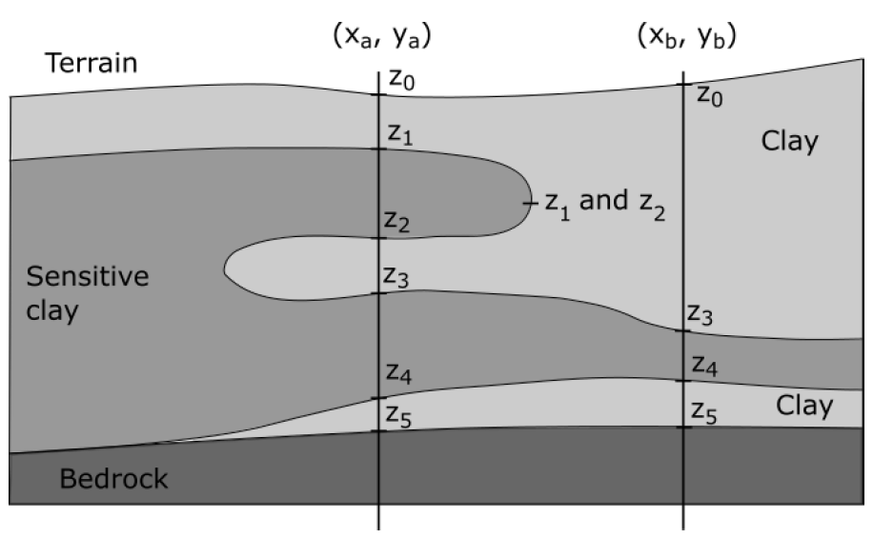

Figure 8 Construct data for soil layers

To perform three-dimensional landslide modeling, we employed spatial discretization of material points to represent the terrain and various soil layers. We utilized LeapFrog data (Multiconsult, 2021a-b) containing detailed digital elevation information for the terrains and all soil layers, as depicted in Figure 6 and Figure 7 respectively. These data include the coordinates of layer interfaces labeled as z0 – z5 as depicted in Figure 8. To convert this data into numerical spatial discretization, we applied the 3D Material Point Method (MPM) discretization technique (Fernandez et al., 2020).

In this technique, we generated material points from the bottom of the bedrock up to the terrain level. Subsequently, based on the vertical coordinates of these material points, we assigned them to specific soil layers. For instance, material points falling between z3 and z4 were designated to the quick clay layers. This approach facilitated the creation of a 3D MPM model capable of accommodating arbitrary and complex distributions of soil layers and terrain within the analysis domain.

In summary, we transformed the LeapFrog data into different soil layers using 3D spatial discretization of material points, as demonstrated in Figure 9 for terrain, Figure 10 for bedrock, and Figure 11 for quick clay. The 3D model in this study featured a grid resolution of 1 meter with 8 material points per element, resulting in a distribution of 117,552,926 material points across a structured grid comprising 45,924,000 elements. Specifically, there were 89,471,948 material points in the non-sensitive clay and 28,080,978 material points in the quick clay layer.

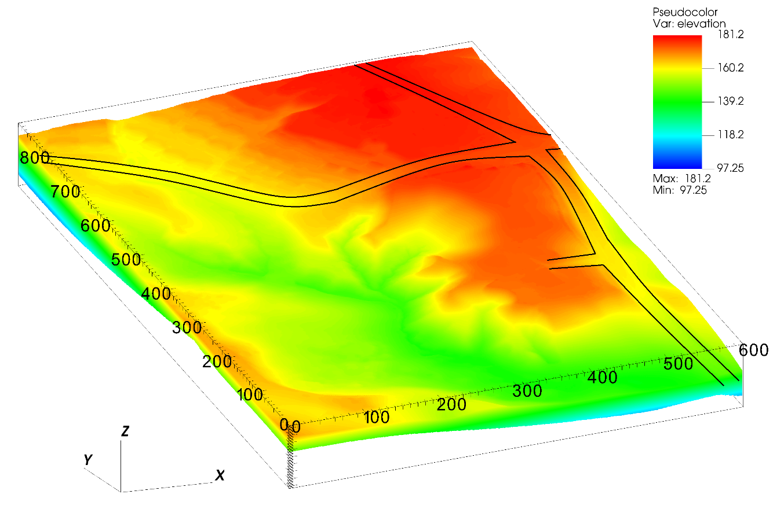

Figure 9 Terrain elevation in numerical model

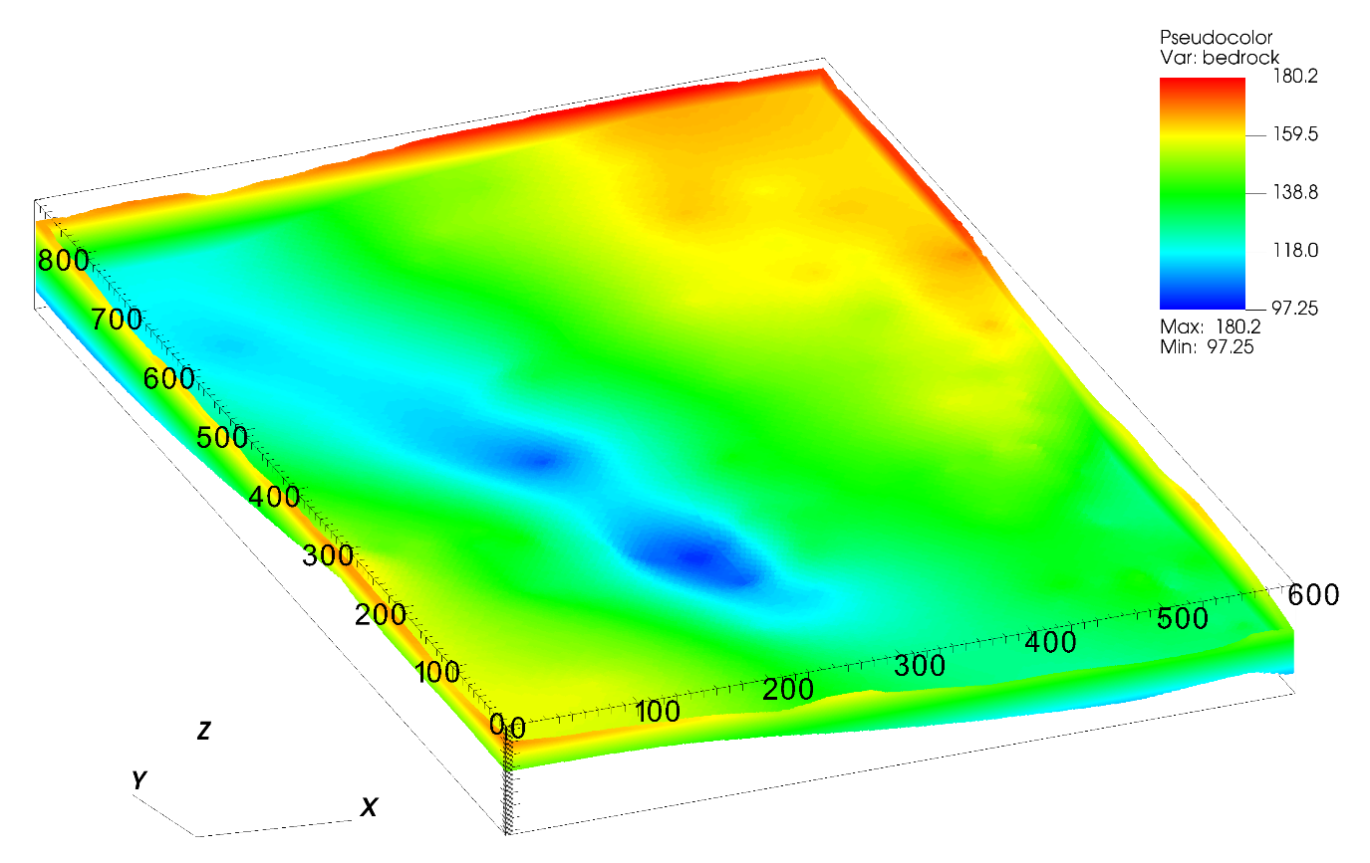

Figure 10 Bedrock elevation in numerical model

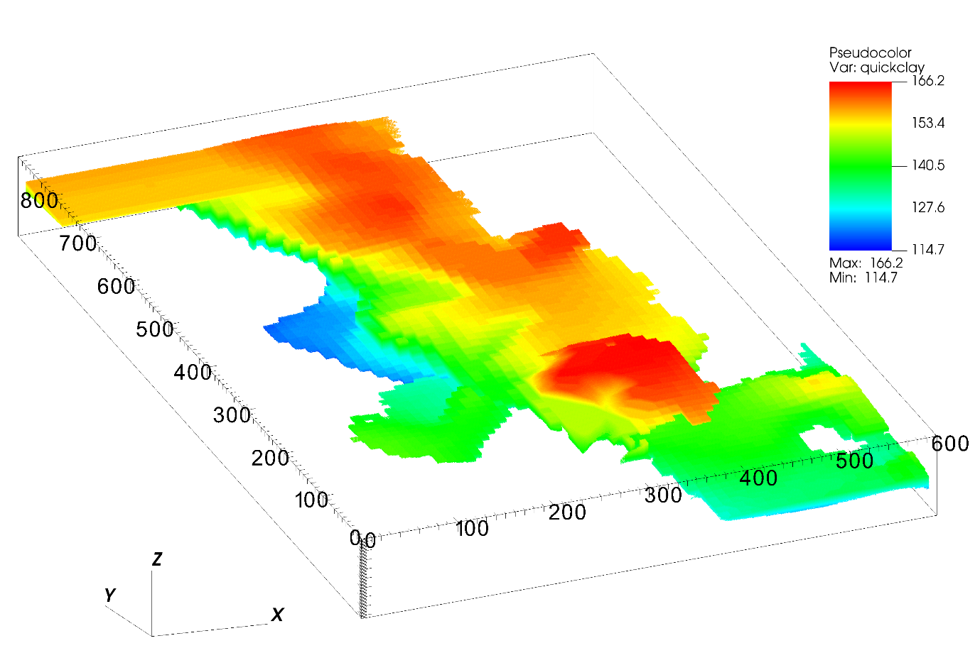

Figure 11 Quick clay elevation in numerical model

# Assigning 3D soil properties for material points from CPTUs

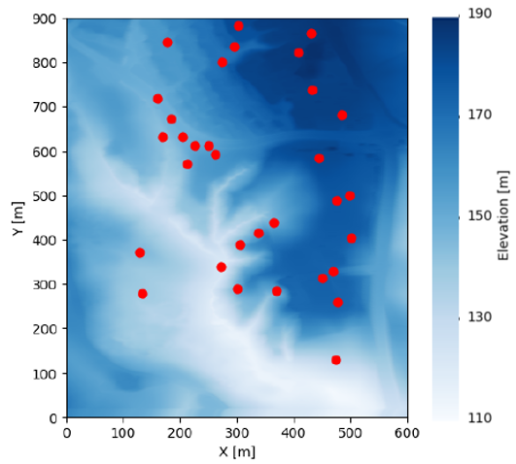

Figure 12 Location of CPTU boreholes

Shear strength values are interpolated across the model domain from 33 interpreted boreholes at the site. The shear strength values in the boreholes are interpreted from available CPTu profiles and laboratory tests (Multiconsult, 2021a-a) and reduced to linear profiles along the depth for improved interpretability. Prior to implementing interpolation, each borehole was discretized into 200 points along the vertical axis. The values of the undrained shear strength were interpolated at these points along the boreholes.

The interpolation of undrained shear strength values from the borehole locations to the rest of the domain was conducted with a Radial Basis Function (RBF) approximation (Rippa, 1999; Virtanen et al., 2020). Let $f\left(d\right);d={\left[x,y,z\right]}^{T}$ be a real-valued function in the three spatial dimensions that we wish to approximate with RBF. An RBF approximation to $f\left(d\right)$ is a function s that takes the form (Rippa, 1999):

|  |  |
| --- | --- |
|  | (3) |

where $φ$ is a fixed real-valued radial basis function and $\left\| ∙ \right\|$ denotes the Euclidean norm. The points $d_{i};i=1,…,n$ are called the centers of the RBF approximation (Rippa, 1999). RBF approximation was selected due to its very simple structure and efficient performance on unstructured interpolation on large numbers of points. Some of the commonly used radial basis functions include gaussian, cubic, linear, inverse, and multiquadric (Rippa, 1999; Virtanen et al., 2020). Radial basis functions commonly include a tuning parameter that needs to be adjusted as it can significantly affect the performance of the approximation. Given $n$ locations, $d_{i};i=1,…,n$, and a vector of observations $f={\left[f_{1},…,f_{n}\right]}^{T}$, where $f_{i}=f\left(d_{i}\right)$, we aim to find a function $s\left(d\right)$ of the form in Eq. 1 that interpolates the observations such that (Rippa, 1999):

|  |  |
| --- | --- |
| $s\left(d_{i}\right)=f_{i};i=1,…,n$ | (4) |

Solving the interpolation in Eq. 2 is equivalent to solving a system of linear equations [1]:

|  |  |
| --- | --- |
| $$Aa=f$$ | (5) |

for the coefficient vector $a={\left[a_{1},…,a_{n}\right]}^{T},$ where $A=A_{ij}=φ\left(\left\|d_{i}-d_{j}\right\|\right)$.

The linear radial basis function was used for the interpolation of undrained shear strength values after testing a wide range of radial basis interpolation functions. Selection is primarily based on making sure that shear strength profiles along the depth are realistic and that the computation is efficient. Shear strength profiles are typically characterized by an increase in undrained shear strength with depth and approximately constant values of undrained strength in the dry crust layer. In addition, the linear basis function does not require tuning parameters (Virtanen et al., 2020). An RBF interpolation of the undrained shear strength values was implemented using the Python SciPy library (Virtanen et al., 2020).

Using this interpolation technique, we can determine the undrained shear strength of the entire layers, as shown in Figure 13 at the ground surface and Figure 14 for the quick clay layer at top of the transition to quick clay layer. The undrained shear strength is correlated with the elevation such that the deeper the soil layer, the higher the undrained shear strength. That is consistent with the CPTUs data in which the undrained shear strength increases linearly with depth in the normally consolidated clay.

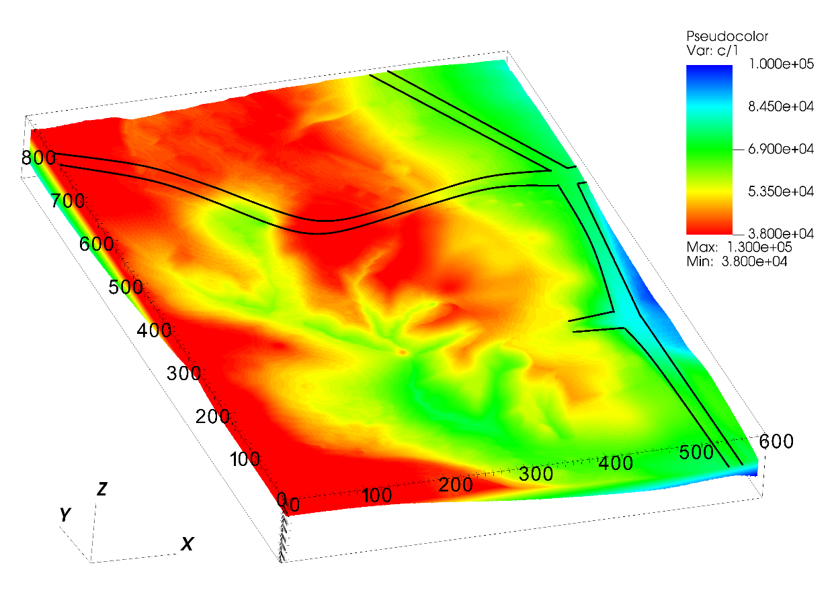

Figure 13 The undrained shear strength at the ground surface

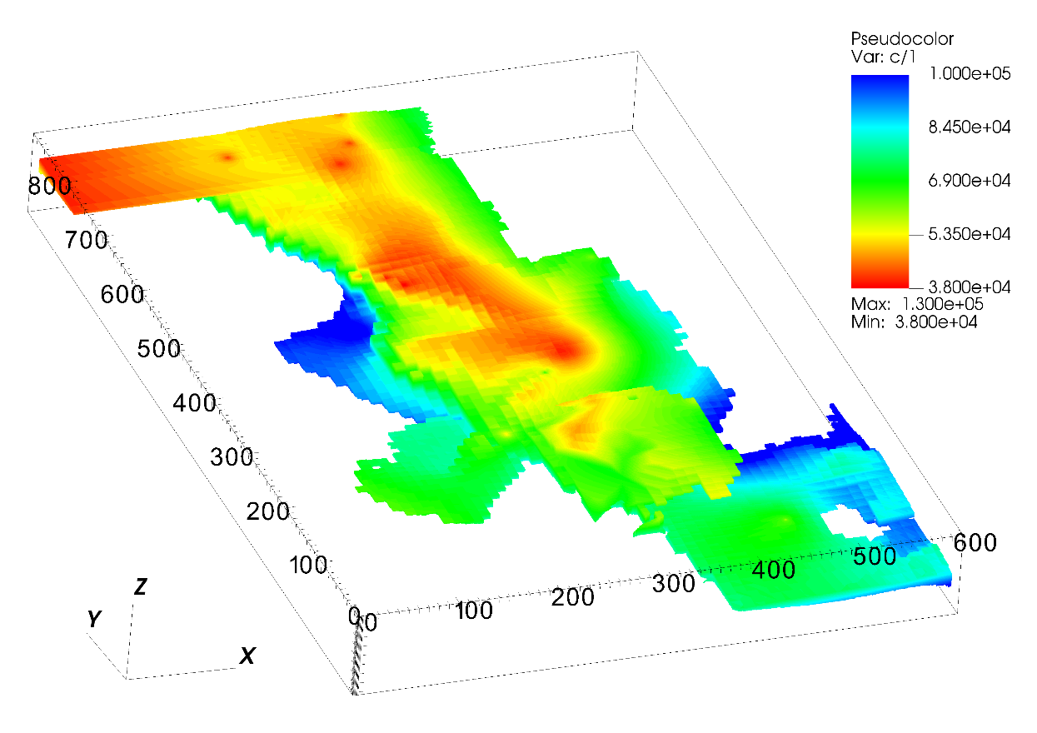

Figure 14 The undrained shear strength of the quick clay layer

# Numerical model

## Generalized Interpolation Material Point Method

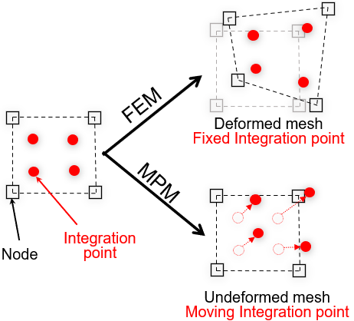

Figure 15 Material Point Method (MPM) vs Finite Element Method (FEM)

The Material Point Method (MPM) is a continuum method well suited for the solution of dynamic large deformation problems. Comparing the MPM to the Finite Element Method where the integration points are fixed in the deformed mesh, the MPM allows the integration points, or more precisely the material points, to move freely in the background mesh (see Figure 15). As a result, large deformations in solid mechanics can be modeled for materials that are history dependent. Several years later, Bardenhagen and Kober (2004) proposed the Generalized Interpolation Material Point Method (GIMP), which significantly improves the robustness and accuracy of the original Material Point Method. The GIMP version of the material point method is exclusively used in this paper, as it is coded in the open-source Uintah computational framework.

## Geotechnical parameters

Table 1. Parameters in the progressive failure of the quick clays slope

|  |  |  |  |  |
| --- | --- | --- | --- | --- |
| Layer | $$s_{u,ref }$$ (kPa) | $$s_{ur}$$ (kPa) | St = |  |
| non-sensitive clay | CPTUs data | 10 | 1-10 | 25% |
| quick clay | CPTUs data | 0.5 | 20-100 | 25% |

Based on the soil investigation (Multiconsult, 2021a), the average soil density is 19.5 kN/m3 for all layers. For undrained condition, the Young’s modulus is set to be 10 MPa with the Poisson’s ratio of 0.49. Sensitivity analysis showed that elastic parameters have negligible effects on the numerical results.

According to NS8015 (Toril Wiig, 2020), quick clay has a remolded undrained shear strength of less than 0.5 kPa. Therefore, the quick clay layers were calculated using remoulded undrained shear strengths of 0.5 kPa. Meanwhile, CPTUs data indicated that the minimum undrained shear strength in some boreholes is 11 kPa. Therefore, we select a remoulded undrained shear strength of 10kPa for the non-sensitive clay layer. The sensitivity of the clay layer is between 1-10 and the sensitivity of the quick clay layer is between 20-100, which corresponds to the results of the fall cone tests in the Gjerdrum landslide (Multiconsult, 2021a). Due to the mesh dependence of this parameter, the parameter ${}_{95}$ (accumulated shear strains required to obtain 95% reduction of shear strength) governing the softening rate is scaled in accordance with the mesh. In several studies (Rogstad, 2021; Tran & Solowski, 2019), ${}_{95}$ was set to be approximately 100% for mesh sizes of 0.25 m. Using the scaling law, it corresponds to ${}_{95}$ of approximately 25% for a mesh size of 1 m. The constitutive soil parameters for the study are summarized in Table 1.

# Numerical results

## Phase 1: pre-failure initial stress condition

Phase 1 of the simulation is dedicated to establishing the initial stress conditions. All layers are placed within the rigid bedrock, while all side boundaries operate under Neumann boundary conditions, which facilitates the free movement of debris out of the domain in Phase 2. Phase 1 involves the generation of initial stresses through gravity loading, utilizing estimated topography data from 2007 and incorporating the undrained shear strength of the soil. A density value of 1950 kg/m³ for saturated clay is considered during this process to establish the initial total stress condition. To expedite equilibrium attainment, numerical damping is applied, ensuring efficient progression in the simulation. It is important to note that the numerical damping introduced in Phase 1 is later removed during the second phase of the simulation, allowing for a more precise representation of the system's behavior during the retrogressive failure analysis in Phase 2. To initiate the calculation in Phase 2, the topographical differences between 2015 and 2007 were removed to mimic erosion. This unloading process acted as a trigger for the initiation of retrogressive slides.

## Phase 2: initiation of the first slides

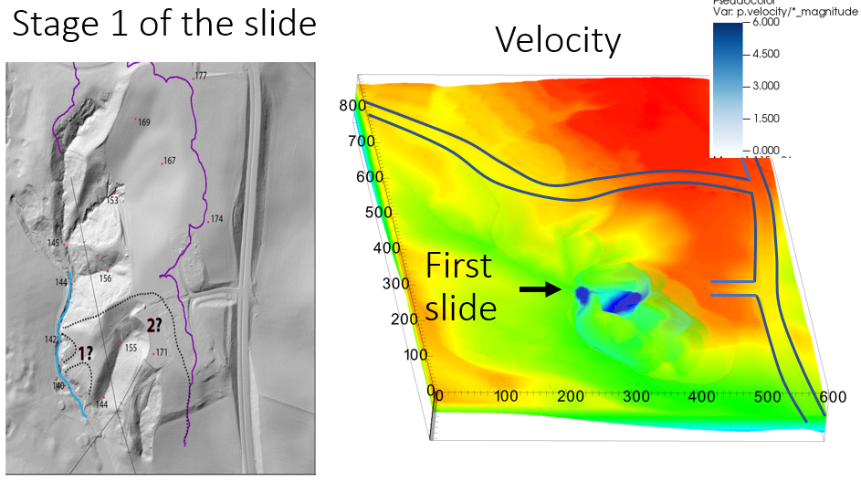

Figure 17 Numerical prediction of the location of the first slides

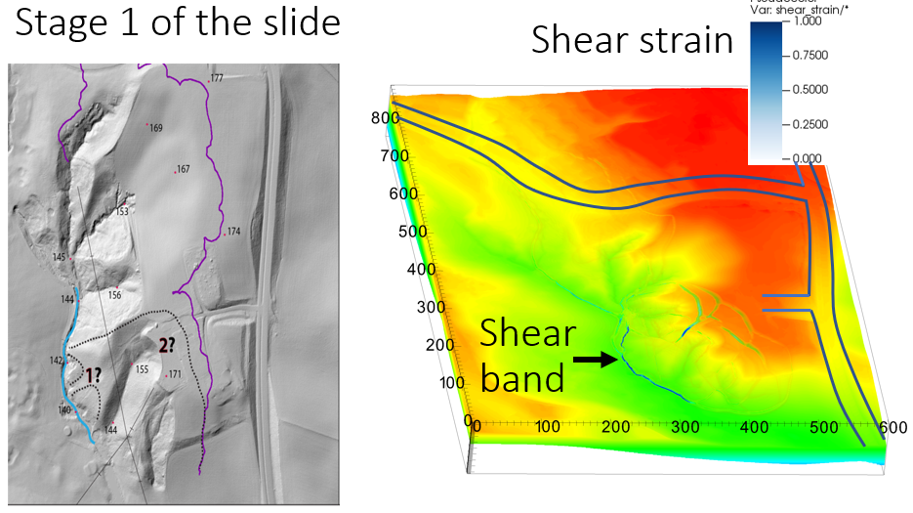

Figure 18 Development of shear band during the initiation of the first slides

The Gjerdrum landslide was initiated by first local instability near Tistilbekken. It is likely that one or more small slides were triggered down the eastern slope of Tistilbekken during the early morning of 30th December 2020. As we transitioned from Phase 1 to Phase 2 and removed the soil mass near the slope's toe in our slope stability analysis, it became evident that these slopes initially exhibited very low stability, with a safety factor of approximately 1. Due to the instability and the quick clays, the numerical model showed that first slides occurred without additional numerical intervention. Here are some numerical observations during the initiation of the slide:

* The numerical model indicated the location of the first slides in a manner that reported in the Gjerdrum report (Ryan et al., 2021) as illustrated in Figure 17 where the blue color indicates the speed of the first soil blocks. At the location of the first slide, the quick clay layers are shallow just few meters below the ground (at 166 m in Figure 11, compared to the terrain's elevation of around 170 m in Figure 9).
* In addition to predicting the movement of the first slides, the numerical model showed a 3D propagation of shear bands or a very thin weak layers along the toe slope near the creek as illustrated in Figure 18 where the blue color indicates the magnitude of the shear strain. These shear band were primarily governed by the morphology of the quick clay layers and initiated the retrogressive failure of this quick clay landslide.

## Phase 2: retrogressive failure mechanism after the first slide

This section illustrates the retrogressive failure in the 3D numerical model and draws a comparison with the on-site observations. The initial slides in the Gjerdrum landslides were reported to trigger a pattern of backward-propagating fractures, following which the landslide masses flowed southwestward (stages 0, 1, 2 in Figure 3). The quick clay on the slope west of Holmen was stirred and flowed away, leaving a steep, unstable slope to the north. Consequently, retrogressive failure occurred with quick clay debris flowing mainly southward. In Stage 7, the landslide event hit Nystulia, and the landslide masses destroyed buildings along the western side of the landslide area.

Using the numerical model, the entire retrogressive failure can be captured as shown in Figure 19 for snapshots taken at 20 seconds, 50 seconds, 60 seconds, and 120 seconds, with the blue color indicating the magnitude of the shear strains. Approximately 20 seconds after the first slide, the soil remoulded and flowed southwestward (the black arrow in Figure 20 indicates the direction of the landslide mass movement in the numerical model). The shear bands/fractures propagated to the north at 50 seconds (see the black dashed line in Figure 20). Retrogressive failure occurred immediately following the propagation of the shear band at 60 seconds, with remoulded quick clay flowing mainly to the south. On the east side of the landslide, the soil mass collapsed after 60 seconds due to the remoulded clay continuing to liquefy. Further soil movement to the west was induced because of this. This soil movement was overestimated in comparison with what was observed on site. At 120 seconds in the simulation, the final deposition can be observed.

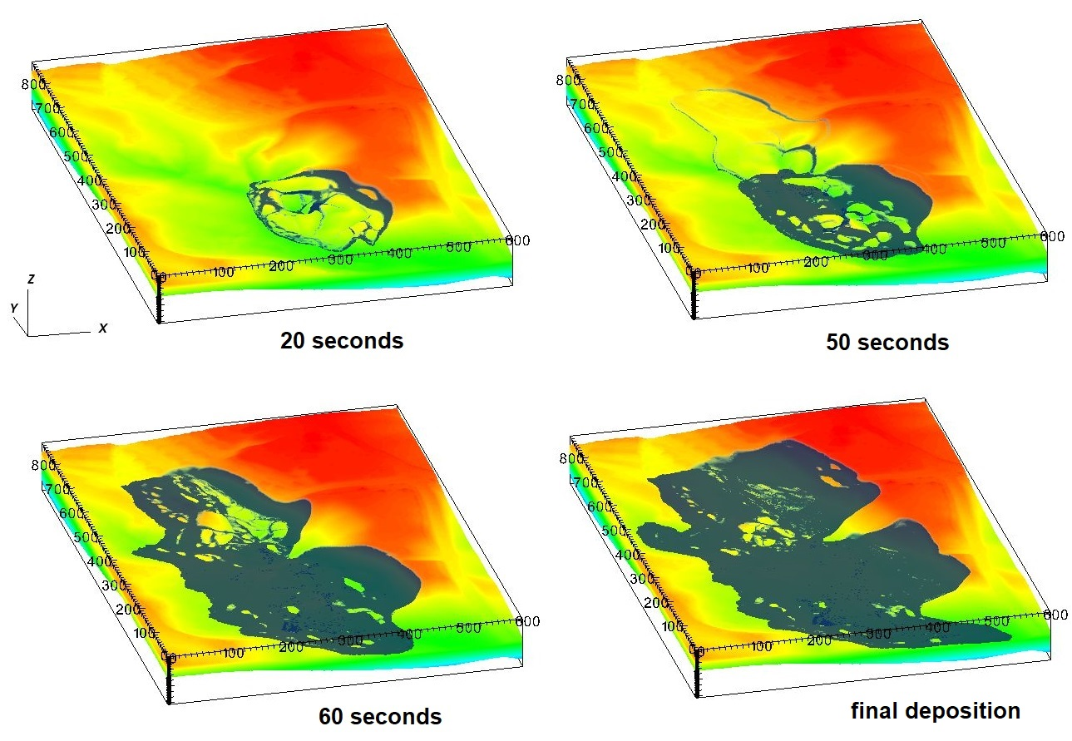

Figure 19 Development of soil movement after the first slides

In Figure 20, we plotted two cross sections A-A and B-B to better understand the simulation process. These cross-sections were chosen because they captured the main directions of flow. The cross-section A-A captures the first part of the landslide flowing westward, whereas the cross-section B-B captures the part of the landslide flowing southward. According to the Varnes' classification of landslides (Hungr et al., 2014), the cross section A-A showed the failure mechanism of the first slide as **clay rotational slides**. This is due to the sliding of the soil mass along a rotational rupture surface with rapid movement of the quick clays shown in Figure 21. The cross section B-B, however, clearly displayed a **retrogressive flow slide** according to Varnes' classification (Hungr et al., 2014). The failure is characterized by a rapid flow of liquefied sensitive clays with multiple retrogressive clay blocks dislocated and remoulded as illustrated in Figure 22.

Overall, the simulation captures satisfactorily what happen on the field with overestimation of the soil mass movement to the west at the end of the retrogressive process. One interesting note here is that the shear band propagation did not necessarily propagate along the quick clay later based on the numerical results as shown in Figure 20 and Figure 21.

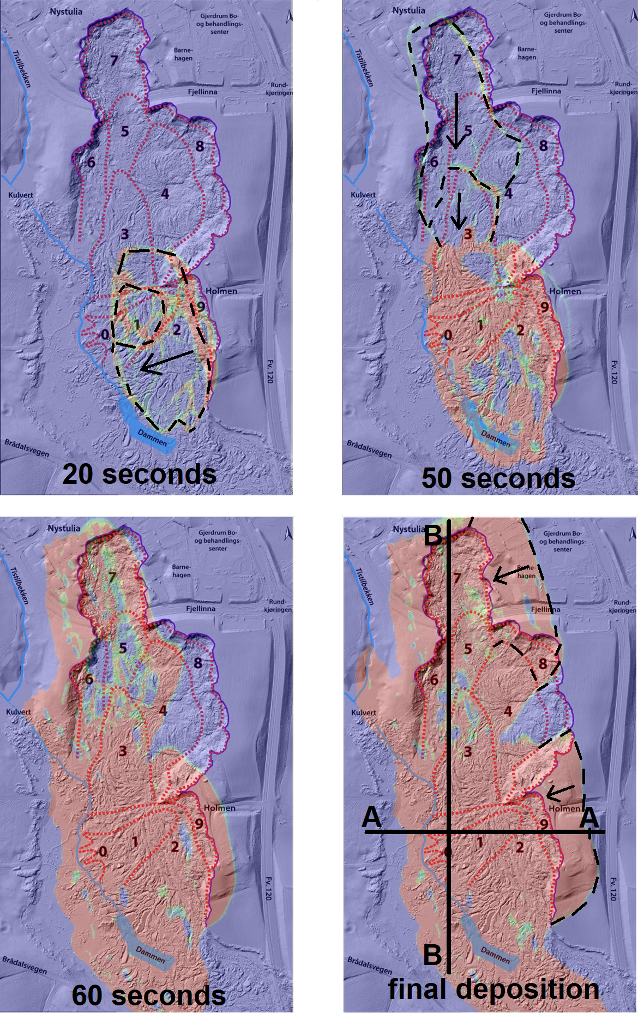

Figure 20 Development of shear band of the first slides

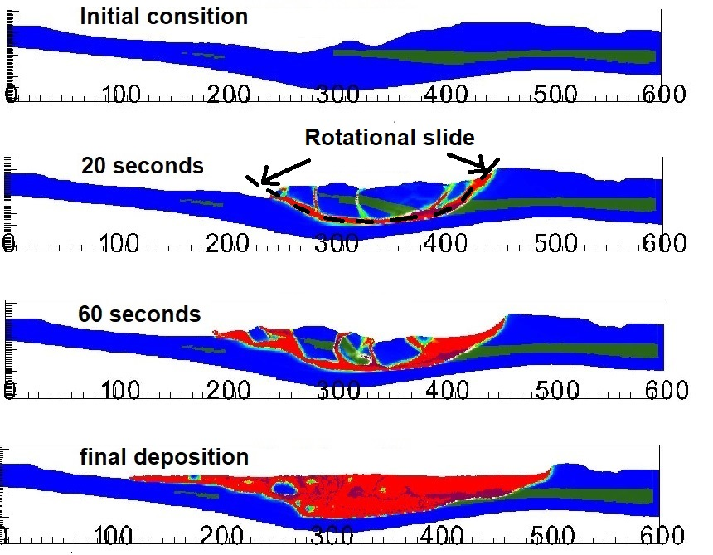

Figure 21 Development of shear bands in cross section A-A

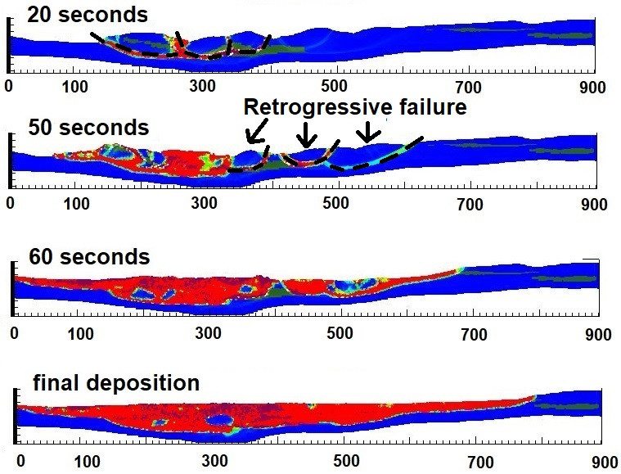

Figure 22 Development of shear bands in cross section B-B

## Influence of softening rate in retrogression distances

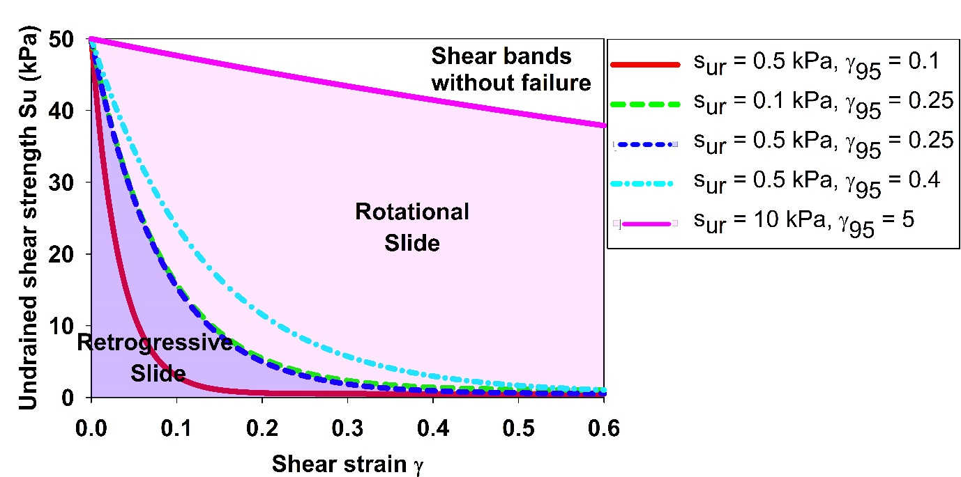

Figure 23 Influence of stress-strain curve in the failure mechanism

In this section, we examine the influence of softening rate on the failure mechanism of sensitive clay landslides. The undrained shear strength is governed by equation (1). Thus, softening behavior is governed by two parameters. The first parameter is the remoulded undrained shear strength of the clay sur. The second parameter is the accumulated shear strain required to obtain a 95% reduction in shear strength γ95. It is important to note that the former reflects the sensitivity of clay St, while the latter controls how quickly a material will soften. A sensitivity analysis revealed that there are three different mechanisms as illustrated in Figure 23 that depend on the softening rate of the material:

1. The shear bands develop without visual failure: there is no movement of the soil mass. It shows that shear bands emerge as shown in Figure 18 but with a smaller magnitude of shear strain. The failure mechanism is associated with clay with low sensitivity and low softening rate, with the remoulded undrained shear strength of 10 kPa and ${}_{95}$ equal to 5.
2. Rotational slides: If the clay has a higher sensitivity and a higher softening rate, rotational slides will occur as the major failure mechanism as illustrated in Figure 21. Therefore, the retrogressive distance was lower than what was observed on site as shown in Figure 24.
3. Retrogressive slides: When the clay has an extremely high sensitivity and significant rate of softening, such as the remoulded undrained shear strength of 0.5 kPa and ${}_{95}$ less than 0.25, retrogressive slides are observed with the failure mechanism shown in Figure 22. As a result, the retrogressive distance was higher and closer to what was observed on site as shown in Figure 25. Reducing either the remoulded undrained shear strength and/or ${}_{95}$ from the threshold $s_{re}$ =0.5 kPa; ${}_{95}$ = 0.25 had negligible effects on the final retrogressive distances because the landslides almost reached the vicinity of the bedrock layer.

Our study demonstrates the influence of softening rate of the materials on the failure mechanism of the quick clay landslides. However, this analysis is based on the hypotheses that (a) each layer of soil is homogeneous, and the undrained shear strength were calculated from equation (1) that was used to average the mechanical behavior of the clay; (b) the softening law was constructed with the mesh size of 1 m with scaling law to prevent the strain localization. This scaling method has been shown to mitigate mesh dependence in landslide analysis (Tran & Solowski, 2019). Therefore, numerical analysis using other mesh sizes require scaling adjustment.

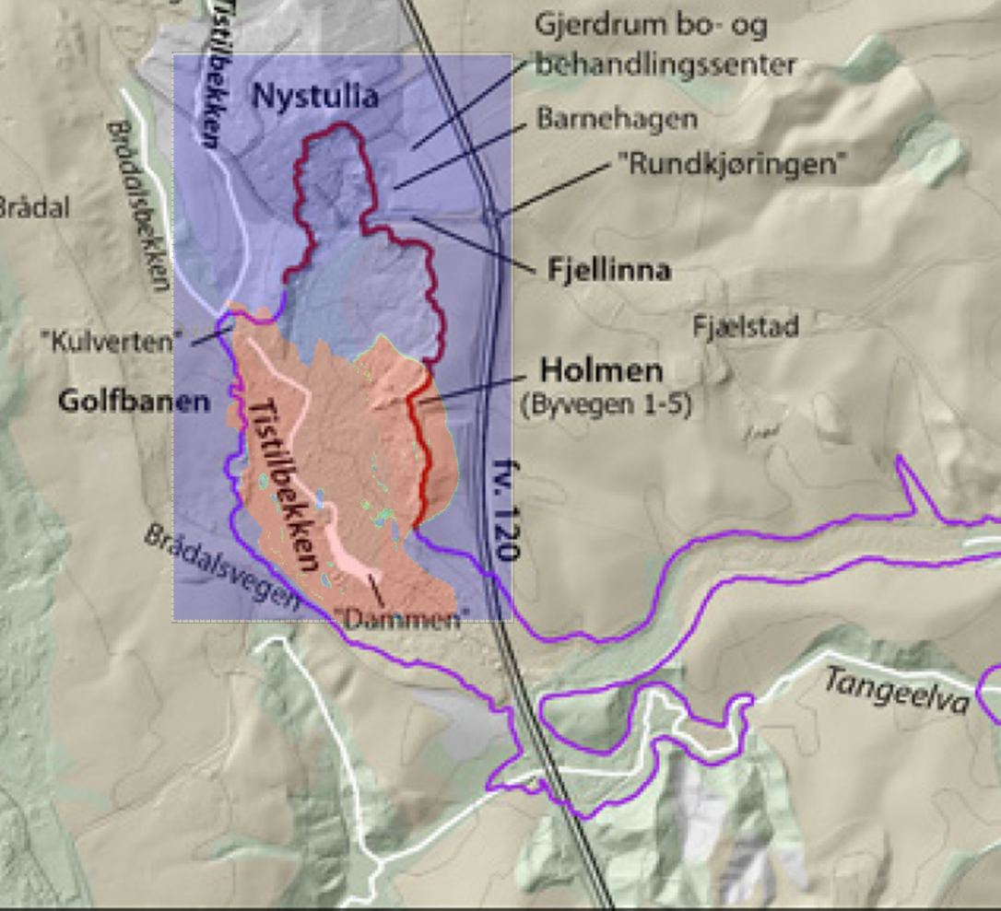

Figure 24 Prediction of retrogression distance in the case of rotational slides

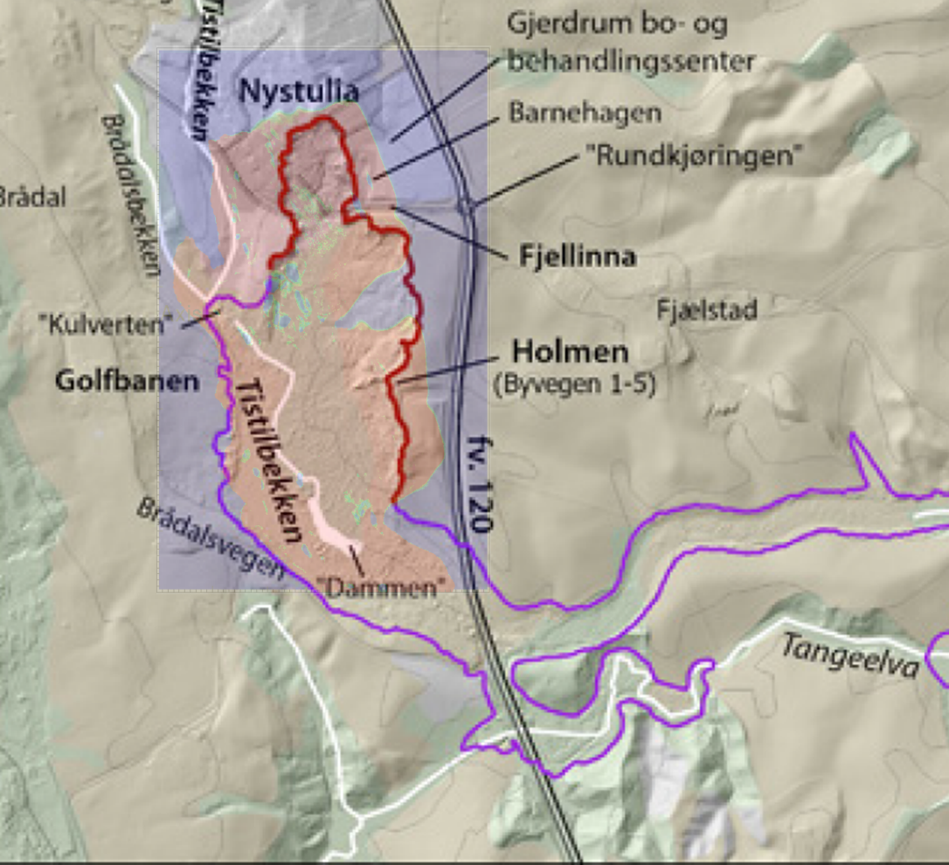

Figure 25 Prediction of retrogression distance in the case of retrogressive slides

# Conclusion

In the existing literature, numerical analyses of sensitive clay landslides are often conducted using 2D models. Nevertheless, there are evidence that 2D and 3D models can yield notably distinct outcomes. Consequently, we have developed a 3D model specifically tailored for analyzing the retrogressive failure of the quick clays. This study rigorously compares our model with real-world observations from the Gjerdrum landslides, revealing a high degree of alignment between our numerical predictions and on-site observations.

One distinctive aspect of our model is its ability to integrate three critical elements: (1) the reconstruction of a 3D terrain coupled with intricate layers of quick clays; (2) the assignment of 3D soil properties based on Cone Penetration Test (CPTU) data; and (3) the computation of retrogressive distances and the onset of failure within a unified framework, employing large deformation analysis grounded in the Material Point Method. Our model provides an avenue to explore the dynamic behavior of sensitive clays in three dimensions. In addition to serving as an alternative to empirical methods, it offers the capability to predict retrogressive distances.

Moreover, our research quantifies the impact of the softening rate on sensitive clay layers, which is a critical factor governing the failure mechanisms of sensitive clay landslides. Notably, our numerical results indicate that the shear band may not necessarily need to propagate exclusively along the quick clay layers.

Nevertheless, it's essential to acknowledge certain limitations of our model: (1) The 3D numerical model is presently limited to total stress analysis at a slope scale; (2) Accurate detection of sensitive clay layers and precise characterization of soil properties are prerequisites to avoid overestimation of retrogressive distances in numerical predictions; (3) The computational demands are substantial, necessitating access to high-performance computing facilities.

To achieve a more comprehensive understanding of the realistic failure mechanisms of sensitive clay landslides, the pursuit of effective stress analysis could be a promising avenue for future research.

# Acknowledgements

The authors gratefully acknowledge Dr. Samson Abate Degago from Norwegian Public Roads Administration for constructive discussion. The research received support from the European Union’s Horizon 2020 research and innovation program under the grant agreement 101022007. The computations were performed on High Performance Computing resources provided by UNINETT Sigma2 - the National Infrastructure for High Performance Computing and Data Storage in Norway.

# Code availability

Instructions for replicating the numerical results in this paper are given at the open-source platform GitHub. Also, the open-source code is shared in this platform for interested users to take up and make use of the results.

# Reference

Alison McQuillan, N. B., T. Yacoub. (2021). On the comparison of 2D and 3D stability analyses of an anisotropic slope. RIC2021: Rocscience International Conference, Toronto, Canada.

Dey, R., Hawlader, B., Phillips, R., & Soga, K. (2015). Large deformation finite-element modelling of progressive failure leading to spread in sensitive clay slopes. *Geotechnique*, *65*(8), 657-668. <https://doi.org/10.1680/geot.14.P.193>

Fernandez, F., Vargas, E. D., & Velloso, R. Q. (2020). A 3D discretization procedure for the material point method (MPM). *Computational Particle Mechanics*, *7*(4), 725-733. <https://doi.org/10.1007/s40571-019-00303-7>

Hungr, O., Leroueil, S., & Picarelli, L. (2014). The Varnes classification of landslide types, an update. *Landslides*, *11*(2), 167-194. <https://doi.org/10.1007/s10346-013-0436-y>

J.S. L’Heureux, O. A. H., A.P. Paniagua-Lopez, S. Lacasse. (2018). Impact of climate change and human activity on quick clay landslide occurrence in Norway. Second JTC1 Workshops on Triggering and Propagation of Rapid Flow-like Landslides, Hong Kong.

Liu, Z. Q., L'heureux, J. S., Glimsdal, S., & Lacasse, S. (2021). Modelling of mobility of Rissa landslide and following tsunami. *Computers and Geotechnics*, *140*. <https://doi.org/ARTN> 104388

10.1016/j.compgeo.2021.104388

Locat, A., Jostad, H. P., & Leroueil, S. (2013). Numerical modeling of progressive failure and its implications for spreads in sensitive clays. *Canadian Geotechnical Journal*, *50*(9), 961-978. <https://doi.org/10.1139/cgj-2012-0390>

Locat, A., Leroueil, S., Bernander, S., Demers, D., Jostad, H. P., & Ouehb, L. (2011). Progressive failures in eastern Canadian and Scandinavian sensitive clays. *Canadian Geotechnical Journal*, *48*(11), 1696-1712. <https://doi.org/10.1139/T11-059>

Multiconsult. (2021a-a). *0226192-01-RIG-BER-001 rev00 Teknisk beregningrapport – Parametere*. O. Multiconsult.

Multiconsult. (2021a-b). *10226192-01-RIG-BER-001 rev00 Teknisk beregningrapport. Parametere* (Oslo: Multiconsult, Issue.

Rippa, S. (1999). An algorithm for selecting a good value for the parameter c in radial basis function interpolation. *Advances in Computational Mathematics*, *11*(2-3), 193-210. <https://doi.org/Doi> 10.1023/A:1018975909870

Ryan, I., Ottesen, H. B., Nordal, S., Bruvoll, A., Hæreid, G. O., Solberg, I.,, & al., e. (2021). *Årsakene til kvikkleireskredet i Gjerdrum 2020*.

Toril Wiig, S.-A. S. o. E. D. H. (2020). *Sikkerhet mot kvikkleireskred*. N. v.-o. energidirektorat.

Tran, Q. A., & Solowski, W. (2019). Generalized Interpolation Material Point Method modelling of large deformation problems including strain-rate effects - Application to penetration and progressive failure problems. *Computers and Geotechnics*, *106*, 249-265. <https://doi.org/10.1016/j.compgeo.2018.10.020>

Virtanen, P., Gommers, R., Oliphant, T. E., Haberland, M., Reddy, T., Cournapeau, D., Burovski, E., Peterson, P., Weckesser, W., Bright, J., van der Walt, S. J., Brett, M., Wilson, J., Millman, K. J., Mayorov, N., Nelson, A. R. J., Jones, E., Kern, R., Larson, E., . . . Contributors, S. (2020). SciPy 1.0: fundamental algorithms for scientific computing in Python (vol 33, pg 219, 2020). *Nature Methods*, *17*(3), 352-352. <https://doi.org/10.1038/s41592-020-0772-5>

Zhang, X., Wang, L., Krabbenhoft, K., & Tinti, S. (2020). A case study and implication: particle finite element modelling of the 2010 Saint-Jude sensitive clay landslide. *Landslides*, *17*(5), 1117-1127. <https://doi.org/10.1007/s10346-019-01330-4>